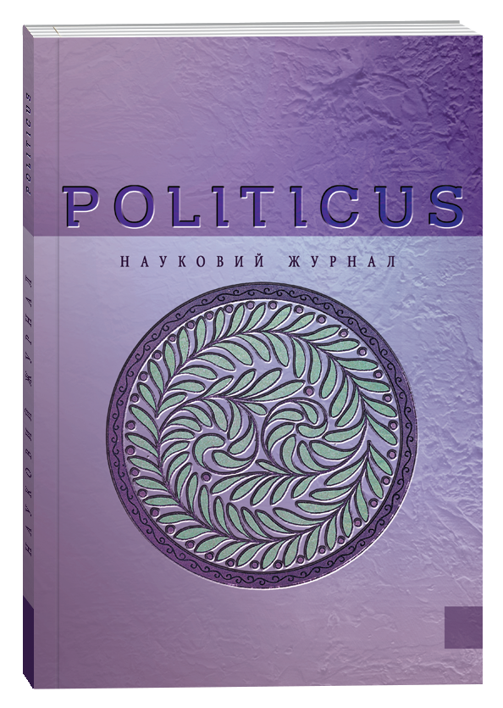
ISSN 2414-9616

To the attention of the authors of scientific journal “Politicus”

Scientific journal “Politicus” publishes articles on issues related to theory and history of political science, political institutions and processes, political culture and ideology, ethnopolitology and ethno-state studies as well as issues of other branches of political science, written in Ukrainian, English, German or Polish.

Scientific journal «Politicus» is included in the List of scientific professional editions of Ukraine (category “B”) on Political Science (specialty: 052 «Political Science») according to the Order of the Ministry of Science and Education of Ukraine as of 17.03.2020 № 409 (Annex 1).

The journal is included in the International scientometric database Index Copernicus International (the Republic of Poland).
Editorial board of the journal carries out receiving and registration of articles DOI.

JOURNAL SECTIONS
1. Theory and history of political science;
2. Political institutions and processes;
3. Political culture and ideology;
4. Political issues of the international systems and global development;
5. Ethnopolotology and ethnopolitical science.

Scientific journal “Politicus” accepts articles for issue No 6, 2022
before December 27, 2022 inclusively

PROCEDURE FOR MATERIALS SUBMITTING
To publish an article in scientific journal “Politicus” No. 6, 2022, it is necessary to send by December 27, 2022 the following materials to e-mail: editor@politicus.od.ua:
1. article;
2. information about the author.
Editorial board of the journal performs an internal review of the article – a member of the editorial staff examines the article (single-blind review - a reviewer knows the author, but the author doesn’t know the reviewer). In reliance upon the review, the author can receive one of the following answers: - the article is accepted for printing; - refine the article; - the author is refused publishing.
The articles were checked for plagiarism using the software StrikePlagiarism.com developed by the Polish company Plagiat.pl.
Publishing fee is performed after the official confirmation and giving of the payment details by editorial board (the official e-mail: editor@politicus.od.ua).

Submitted materials, which don’t comply with requirements of standards, are not accepted for editing and publishing. Editorial board reserves the right to edit, reduce materials and specify the title. Published materials express authors position that may not coincide with opinion of editorial board. Author is responsible for reliability of facts, statistical data and other materials.

TECHNICAL REQUIREMENTS FOR ARTICLE COMPOSITION
A 4 page; fields: 2 cm (the upper) x 2cm (the bottom), 3 cm (the left) x 1,5 cm (the right); intended paragraph – 1,25 cm; line spacing – 1,5; font – Times New Roman; size: 14.
The volume of the article – from 10 to 20 pages.
It is necessary to use symbols in the text, in accordance with the example: quotes “…”, hyphen (-), dash (–), apostrophe (’).

the structure of article
1. UDC index and journal section are aligned to the left
2. First name, patronymic, and last name of the author(s) (degree and academic rank, job position, postal address of author’s place of employment are carried in the article language, ORCID-code. If the author does not have an ORCID-code, it is possible to get it by following the link https://orcid.org/ The maximum number of authors of the article is three persons.
3. The title of the article has to include no more than 10 words, clarify the core issue, and to be interesting for a wide audience of researchers.
4. Summary (from 250 to 300 words) and key words are in the article language (5-10 words). Summary has to include such necessary elements: topicality of an issue, goal of research, methods and research results.
5. Research article has to involve such structural elements as followings:
Introduction.
Goal and tasks.
Methods of research.
Results. Articles must have an empirical part. Purely theoretical researches will be accepted for publication, if they have a considerable scientific topicality.
Conclusions should not involve an information, which is absent in the main text of article.
Bibliography is performed in accordance with the requirements. The list of used sources is designed in the alphabetical order. The article should refer to foreign sources (not less than 25% of the total number of citations).
References. Author (transliteration), the article title (translit.), the article title (English translation, in square brackets), name of source (translit.), input data (city with notation, in English), and publishing house. Example:
Bilodid, I. K. (Ed.). (1970). Slovnyk ukrainskoi movy: v 11 tt. [The Ukrainian language dictionary]. Kyiv: Nauk. Dumka [in Ukrainian].
6. First name, patronymic, last name, and the author(s) personal information (degree and academic rank, job position, postal address of the author’s place of employment are indicated in another language than the article one.
7. The title of the article in Ukrainian or English (in another language than the article language).
8. Summary (from 250 to 300 words) and key words in English or Ukrainian (in another language than the article language) (5-10 words).
Names and surnames transliteration is performed in accordance with the requirements of the Resolution of the Cabinet of Ministers of Ukraine “On Normalization of Transliteration of the Ukrainian Alphabet by Means of the Latin Alphabet” dated January 27, 2010, No 55.
It is impossible to translate with the help of online services.

PUBLICATION FEE
The amount of publication fee is 900 UAH. In case of exceeding the volume of 12 pages, you will have an additional payment amounting 40 UAH for each additional article page. Bibliography and summary are also included in the general volume of article pages, which is paid.
Payment details are given in the official confirmation letter, which the editorial board send by e-mail (official e-mail: editor@politicus.od.ua).

Authors who submit original articles to No. 6 on the usual terms, incl. publication fee payment, will have the opportunity to publish two of their contributions free of charge
in the upcoming issues throughout 2023.
We keep supporting every scientist during a tough time!

If desired, an author can order a printed copy of the journal. The cost of a printed copy is UAH 800, which is paid in addition to the publication fee.

Journal electronic version will be available on the website on February 27, 2023.

Authors who ordered a printed copy will receive it before March 27, 2023.

Contacts of editors office
SIHE “South Ukrainian National Pedagogical University named after K. D. Ushynsky”
Staroportofrankivska str., 26, Odesa, Ukraine, 65020.
Contact number: +38 095 40 76 410
E-mail: editor@politicus.od.ua
Website: www.politicus.od.ua

